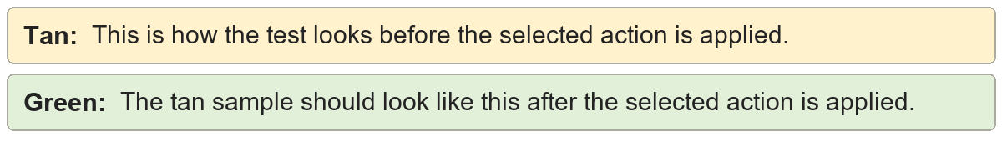
- Manual hyphen bullets | First item in the list
- Manual hyphen bullets | First item in the list

* Manual asterisk bullets | Second item in the list
- Manual asterisk bullets | Second item in the list

1. Manual numbered items | First numbered instruction
- Manual numbered items | First numbered instruction

- List indentation | A real list item
- List indentation | A real list item

